CS-499

Harkamal Sandhu

## Narrative for Enhancement Three: Databases

**Briefly describe the artifact. What is it? When was it created?**

The artifact is a database analysis report based on the Companies database. It was created as part of the DAD 220: Introduction to Structured Database Environments course. The assignment involved analyzing data from various tables within the database, such as Collaborator, Orders, and RMA, and generating reports based on specific queries. The artifact includes SQL commands for data retrieval and analysis, focusing on descriptive analysis and aggregation of data.

**Justify the inclusion of the artifact in your ePortfolio. Why did you select this item? What specific components of the artifact showcase your skills and abilities in software development? How was the artifact improved?**

I selected this artifact for my ePortfolio because it demonstrates my proficiency in database management, data retrieval, and analysis, which are critical skills in software development. This artifact showcases my ability to:

* **Execute SQL commands** for retrieving and analyzing data from relational databases.
* **Perform data aggregation** and generate meaningful reports from raw data.
* **Understand and manipulate database schemas** by describing and querying different tables.
* **Implement advanced data analysis** techniques using MongoDB, demonstrating my ability to transition from relational to NoSQL databases.

The artifact was improved by introducing advanced concepts such as data mining and visualization. The enhancement involved creating a MongoDB interface to store and analyze data, using the MongoDB Aggregation Framework to perform complex data analysis, and ensuring regular software updates and access controls to maintain data security.

**Did you meet the course objectives you planned to meet with this enhancement in Module One? Do you have any updates to your outcome-coverage plans?**

Yes, I met the course objectives planned for this enhancement in Module One. Here is a detailed explanation of the course objectives met:

1. **Design, develop, and deliver professional-quality oral, written, and visual communications that are coherent, technically sound, and appropriately adapted to specific audiences and contexts**

* The enhancement involved documenting and communicating the process of migrating data from a relational database to a NoSQL database, as well as analyzing and visualizing the data. The clear and detailed explanations of the SQL queries, MongoDB commands, and the aggregation pipeline demonstrate my ability to deliver technically sound written communication.

1. **Demonstrate an ability to use well-founded and innovative techniques, skills, and tools in computing practices for the purpose of implementing computer solutions that deliver value and accomplish industry-specific goals (software engineering/design/database)**

* The enhancement demonstrates my ability to use innovative techniques and tools, such as MongoDB for NoSQL database management and the Aggregation Framework for data analysis. The artifact highlights my skills in database design & creation, showcasing my capability to implement solutions that deliver value in data analysis and visualization.

1. **Develop a security mindset that anticipates adversarial exploits in software architecture and designs to expose potential vulnerabilities, mitigate design flaws, and ensure privacy and enhanced security of data and resources**

* The enhancement includes implementing security measures, such as regular software updates and access controls, to protect the database from potential vulnerabilities. This demonstrates my ability to develop a security mindset and ensure the privacy and security of data and resources.

At this time, I do not have any updates to my outcome-coverage plans. The enhancement aligns well with the intended learning outcomes and effectively demonstrates my skills and abilities in database management, data analysis, and software development.

**Reflect on the process of enhancing and modifying the artifact. What did you learn as you were creating it and improving it? What challenges did you face?**

The process of enhancing and modifying the artifact was both challenging and enlightening. Throughout the process of enhancing, I gained valuable insights and skills. One of the most significant learnings was how to transition data from a relational database (MySQL) to a NoSQL database (MongoDB). This experience enhanced my understanding of different database paradigms and their respective strengths and weaknesses.

Additionally, I gained hands-on experience with the MongoDB Aggregation Framework, which proved to be a powerful tool for performing complex data analysis tasks efficiently. Working with the aggregation framework helped me understand how to leverage MongoDB’s capabilities to process and analyze large datasets. This included learning various stages of aggregation, such as $match, $unwind, $group, and $sort, and how they can be combined to extract meaningful insights from data. Another critical learning was the importance of data security and the necessary steps to protect sensitive information. This involved implementing regular software updates to patch known vulnerabilities and setting up access controls to restrict database access to authorized users only. Understanding these security measures reinforced the need for a proactive approach to data protection, ensuring the privacy and security of data and resources in any database system.

The process was not without its challenges. One of the primary difficulties was ensuring the accurate and efficient migration of data from MySQL to MongoDB. This task required careful handling of data formats and structures to ensure compatibility between the two systems. Each database has its way of storing and managing data, and translating these differences accurately was crucial to maintaining data integrity during the migration process.

Imported data into MongoDB compass for analysis is a significant & proactive step.

* MongoDB Compass is a GUI for MongoDB. Assists in optimizing queries and indexes, leading to better database performance, screenshot is as follows:

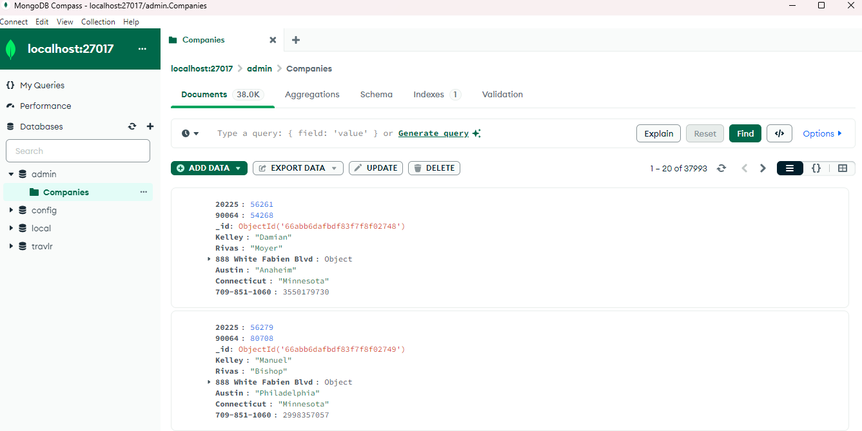

Overall, the process of enhancing and modifying the artifact was a valuable learning experience that allowed me to deepen my database management skills and apply them in a real-world context. The challenges faced during the enhancement process helped me develop problem-solving skills and reinforced the importance of data security in software development.